

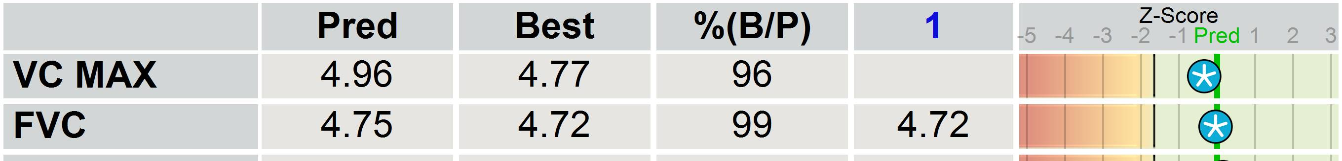
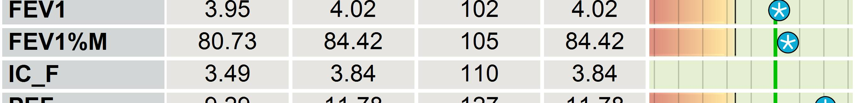
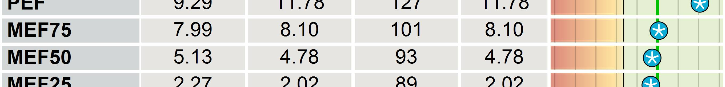

Vyaire Medical GmbH
D-97204 Hoechberg, Leibnizstrasse 7
Phone: +49 (931) 4972-0, Fax: +49 (931) 4972-423
Last Name:
Sam ple
Identification:
CFNSPJO750209
First Name:
SeS
Age:
36 Years
Height:
174 cm
Date of Birth:
09/02/1975
Weight:
80.0 kg
Gender:
male
BMI:
26 kg/m²
Spirometry Flow-Volume
F/V ex
Pre
F/V ex
Pre
10
10
1
5
5
Vol [L]
Vol [L]
0
0
1
2
3
4
5
6
7
8
1
2
3
4
5
6
7
8
5
5
10
10
Best Trial
All Trials
Cooperation: good ( ) moderate ( ) bad ( )
Comment
SPIR_FVC
1 / 1

